

Requirement & Design Specification
SMART LEARNING PLATFORM (JAEN)
Subject: SWD392
Version: 1.0

– Da Nang, June 2026 –

Record of Changes
Version | Date | A* M, D | In charge | Change Description
V1.0 | 1/6 | A | ThanhPTV
*A - Added M - Modified D - Deleted

Contents

I. Requirement Specification 3
I.1 Problem description 3
I.2 Major Features 5
I.2.1 Features for Content Editors are as follows 5
I.2.2 Features for Administrators are as follows 5
I.2.3 Features for Administrators are as follows 5
I.3 System context 6
I.4 Nonfunction Requirements 8
I.5 Functional requirements 9
I.5.1 Use case diagrams 9
I.5.2 Use case descriptions 16
I.5.3 Activity diagrams 23
I.6 Data Requirements 23
II. Analysis models 23
II.1 Interaction diagrams 23
II.2 State diagram 29
III. Design specification 34
III.1 Integrated Communication Diagrams 34
III.2 System High-Level Design 35
III.3 Component and Package Diagram 37
III.4 Detail Design 38
III.5 Database Design 39
IV. Implementation 40
IV.1 Map architecture to the structure of the project 40
IV.2 Map Class Diagram and Interaction Diagram to Code 41
V. Applying Alternative Architecture Patterns 47
V.1 Applying the service-oriented architecture 47
V.2 Applying Service Discovery Pattern in the service-oriented architecture 49

I. Requirement Specification

I.1 Problem description
Purpose: Build a web-based Content Management System (CMS) named JAEN that allows organizations to create, manage, and publish digital content on their websites without requiring technical expertise. The system enables content editors to manage website content directly through an intuitive interface, and allows administrators to manage users, permissions, and system configurations. The system requirements are described as follows:
- The system manages website content organized into pages. When a new page needs to be created, authorized users are responsible for entering the page information including title, slug, metadata, and content blocks into the system. The user can update or delete the page information if there are errors or changes. Pages can be set to published or draft state to control their visibility on the website.
- Each page consists of multiple content blocks (sections), such as text blocks, image blocks, hero sections, and media galleries. When adding or editing a page, content editors can add, reorder, update, or remove individual content blocks. The system preserves the structure and layout of each block type so that the rendered output remains consistent across the website.
- The system provides a media library for managing uploaded assets such as images and files. When a content editor needs to use a new media asset, they can upload it to the media library and attach it to content blocks. The editor can view, search, and delete media files. The system stores metadata for each media asset, including file name, size, type, and upload date.
- To ensure that website content displays correctly before being published, the system provides a real-time content preview feature. When editing any content block, editors can see the changes reflected immediately on the page preview without publishing. This in-context editing experience allows editors to make and verify changes within the live layout of the website.
- The system supports a structured publishing workflow. Content created or modified by editors is saved as a draft by default. When the content is ready, an authorized user can publish the content to make it visible to website visitors. Published content can be unpublished or reverted to draft state if it needs to be revised or temporarily removed.
- The system manages multiple user accounts with different roles and permissions. When a new team member joins, the administrator creates an account and assigns them an appropriate role such as Administrator, Editor, or Viewer. Each role has a defined set of permissions controlling what actions the user can perform within the system. If a user's role changes or they leave the organization, the administrator can update or deactivate their account.
- The system supports authentication for both internal users (staff/editors) and end-users of connected applications. Internal users log in with their registered email and password. The system can also integrate with third-party authentication providers such as GitHub or Google OAuth to allow external collaborators to access the CMS. All authentication sessions are managed securely with token-based mechanisms.
- To support extensibility, the system is built on a plugin architecture. Administrators can install, configure, enable, or disable plugins to extend the system's capabilities, such as adding e-commerce features, form builders, or analytics integrations. Each plugin registers its own content types, widgets, and settings within the system without disrupting core functionality.
- The system maintains a version history for content changes. Each time a page or content block is modified and saved, the system records the change along with the editor's identity and timestamp. Administrators or authorized editors can view the change history and restore a previous version of content if needed.
- The system generates and manages SEO-related metadata for each page, including meta title, meta description, Open Graph tags, and canonical URLs. Content editors can configure these fields per page to optimize search engine visibility. The system validates that required SEO fields are filled before allowing a page to be published.
- To help administrators monitor system activity, the system provides logging and audit trail features. All significant actions such as content creation, modification, deletion, user login, and permission changes are recorded with the actor's identity and timestamp. Administrators can view and filter these logs for review and compliance purposes.
- All users must authenticate before accessing any functionality within the CMS. The system enforces role-based access control so that users can only perform actions permitted by their assigned role. The Administrator has full access to all system functions including user management, plugin configuration, and content oversight.

I.2 Major Features

I.2.1 Features for Content Editors are as follows
- F01: Page Management: View page list, Create new page (set title, slug, metadata), Edit page information, Delete page, Search and filter pages by status (Draft/Published).
- F02: Content Block Editing: Add content blocks to a page (text, image, hero, gallery, etc.), Edit block content inline (in-context editing), Reorder blocks via drag-and-drop, Remove blocks from a page, Configure block-level settings and styles.
- F03: Media Library Management: Upload media files (images, documents), View media library, Search and filter media assets, Attach media to content blocks, Delete media files.
- F04: Content Preview: Preview page content in real-time while editing, View rendered output across desktop and mobile viewports before publishing.
- F05: Publishing Workflow: Save content as Draft, Publish content to make it live, Unpublish published content, Revert published content to Draft state.
- F06: SEO Metadata Management: Configure per-page SEO fields (meta title, meta description, Open Graph tags, canonical URL), View SEO completeness before publishing.
- F07: Version History: View change history of a page, Restore a previous version of content.

I.2.2 Features for Administrators are as follows
- F08: User Management: Create user accounts, View user list, Edit user information, Deactivate or delete user accounts, Search and filter users.
- F09: Role & Permission Management: Create and configure roles (Administrator, Editor, Viewer), Assign roles to users, Update or revoke role assignments.
- F10: Authentication Management: Configure supported login methods (email/password, GitHub OAuth, Google OAuth), Manage active user sessions, Reset user passwords.
- F11: Plugin Management: View installed plugins, Install new plugins, Configure plugin settings, Enable or disable plugins, Uninstall plugins.
- F12: Audit Log: View system activity log (content changes, user logins, permission changes), Filter logs by user, action type, or date range.
- F13: System Configuration: Manage global site settings (site name, default language, timezone), Configure integration settings for external services.

I.2.3 Features for Administrators are as follows
- F14: Learner Authentication: Register account, Login (email/password or OAuth), View and update personal profile, Reset password.
- F15: Learning Profile Setup: Complete onboarding assessment to determine current knowledge level, Select learning goals and topics of interest, Update learning preferences (difficulty level, topic focus) at any time. The system uses this profile to personalize generated content.
- F16: Auto-Generated Learning Material: Based on the learner's profile, knowledge level, and learning history, the system automatically generates suitable learning materials including explanations, examples, summaries, and practice exercises. Learners can request regeneration of content if the current output does not meet their needs. The system adjusts the difficulty and style of generated content based on ongoing learning performance.
- F17: Learning Path Management: View the personalized learning path recommended by the system, Track progress along the learning path, Navigate between topics and lessons, Mark topics as complete.
- F18: Quiz & Assessment: Attempt auto-generated quizzes and exercises aligned with current learning content, View quiz results and explanations for incorrect answers. The system uses assessment results to update the learner's knowledge level and adjust future generated content accordingly.
- F19: Learning History & Progress Tracking: View completed lessons and topics, Review previously generated materials, Track overall progress and performance statistics over time.
- F20: Content Feedback: Rate generated learning materials (helpful / not helpful), Submit comments or flags on content quality. Feedback is used to improve the quality of future auto-generated content for the learner.

I.3 System context

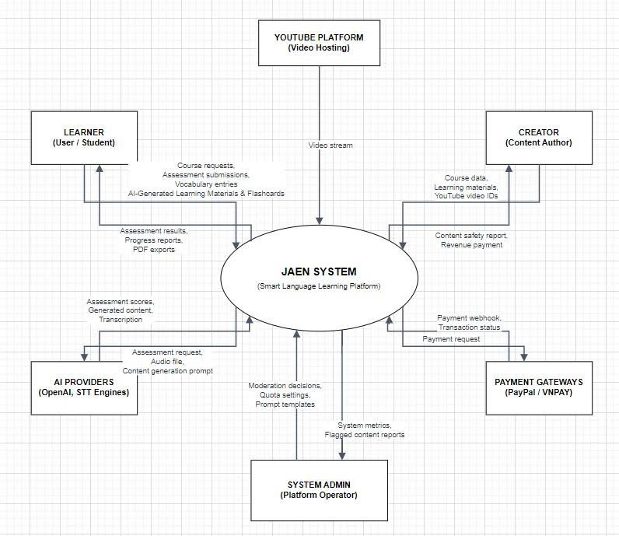

Figure I-1 System context is modeled by a class diagram
Figure 1-1 shows the system context of the JAEN system, illustrating the interactions between the system and its various entities including external users and external systems.
External Users
- Learner: The primary end-user of the system who registers an account, completes a learning profile assessment, receives auto-generated learning materials tailored to their level and goals, attempts quizzes, tracks progress, and provides feedback on generated content.
- Content Editor: Responsible for managing the website's base content including pages, content blocks, and media assets. Editors use the in-context editing interface to create, update, and publish content, and manage SEO metadata for each page.
- Instructor: Responsible for designing course curriculum and learning objectives, reviewing the quality of auto-generated learning materials, monitoring the learning progress of assigned learners, and providing manual feedback or supplementary content when needed.
- Administrator: Manages the entire system including user accounts, role assignments, plugin configurations, authentication settings, and system-wide configurations. The administrator has full access to all functions and monitors system activity through audit logs and analytics reports.
External Systems
- AI Content Generation Service: Provides the core capability of automatically generating personalized learning materials including explanations, examples, summaries, and practice exercises based on each learner's profile, knowledge level, and learning history.
- Google Authentication Service: Provides OAuth 2.0 login services allowing learners and editors to authenticate using their Google accounts.
- GitHub Authentication Service: Provides OAuth 2.0 login services allowing technical users and content editors to authenticate using their GitHub accounts.
- Mailing System: Sends notification and confirmation emails to users, including account registration confirmations, learning progress summaries, and system announcements.
- Media Storage Service: Handles storage and retrieval of uploaded media assets such as images and documents used within the content management layer of the system.

I.4 Nonfunction Requirements
NF-01 Maintainability: The system should be designed to support efficient maintenance and updates. This includes clear traceability among components and modules through detailed documentation of their dependencies, relationships, and interactions. The codebase should follow a modular, plugin based architecture consistent with JAEN's plugin system so that new features can be added or existing ones modified without disrupting core functionality. Comprehensive documentation must be maintained to facilitate onboarding of new developers and smooth system evolution.
NF-02 Usability: The system must offer an intuitive interface for both technical and non-technical users, particularly content editors and learners who may not have a technical background.
- Task completion time (a learner can find and begin a learning session within 3 minutes; an editor can publish a page within 5 minutes).
- Error rate (less than 5% for key tasks such as profile setup, content publishing, and quiz submission).
- User satisfaction (at least 85% satisfaction score based on user feedback).
NF-03 Portability: The system should be accessible across various browsers and devices, as learners may access learning materials from desktop or mobile environments.
- Browser compatibility (latest versions of Chrome, Firefox, Safari, Edge).
- Device compatibility (3 screen sizes, 2 operating systems).
- Responsive design (screen widths from 320px to 1920px).
NF-04 Performance: The system must ensure fast response times, particularly for AI-generated content delivery and real-time in-context editing.
- Page load time (less than 4 seconds for 95% of users).
- Response time (handle 500 users, avg. < 6 seconds).
- AI content generation response time (generated learning materials delivered within 10 seconds of request under normal conditions).
- Stress testing (200 concurrent users, performance degradation < 20%).
NF-05 Security: The system must protect user data and control access strictly based on assigned roles.
- All data transmitted between client and server must be encrypted using HTTPS/TLS.
- Authentication tokens must be managed securely using industry-standard mechanisms (e.g., JWT with appropriate expiration policies).
- Role-based access control must be enforced server-side so that users cannot access or modify resources beyond their permission level.
- Sensitive user data including passwords must be stored using strong hashing algorithms
In this document, we will use UML to construct models across the software development's requirements, analysis, and design phases for the JAEN system. These models are platform-independent and follow the PIM (Platform-Independent Model) approach, ensuring they focus on business logic and functional requirements without being tied to any specific technology platform. In the following sections, we will present the models for each phase requirements, analysis, and design followed by the mapping of these models to source code.

I.5 Functional requirements

I.5.1 Use case diagrams
Based on the described user requirements in Section I.1 and detailed analysis, the JAEN system has been deployed on a web platform consisting of two primary sites: the Learner Site and the Administration Site. Figure I-2 presents the Overview Use Case Diagram for the Learner Site, highlighting key functionalities such as viewing and accessing learning materials, completing assessments, managing learning profile, tracking progress, and providing content feedback. Figure I-3 showcases the Overview Use Case Diagram for the Administration Site, covering essential tasks like managing users, managing roles and permissions, managing plugins, managing content pages, managing media, processing audit logs, and monitoring system analytics. Figures I-4 to I-11 show some Detailed Use Case Diagrams, which further break down the specific use cases for both the Learner Site and the Administration Site.

Tables I-1 to I-6 show descriptions of use cases such as Manage Learning Materials, Generate Learning Content, Submit Assessment, Manage Users, Manage Plugins, and Publish Page. These descriptions will be inputs to building analysis models in Section II.

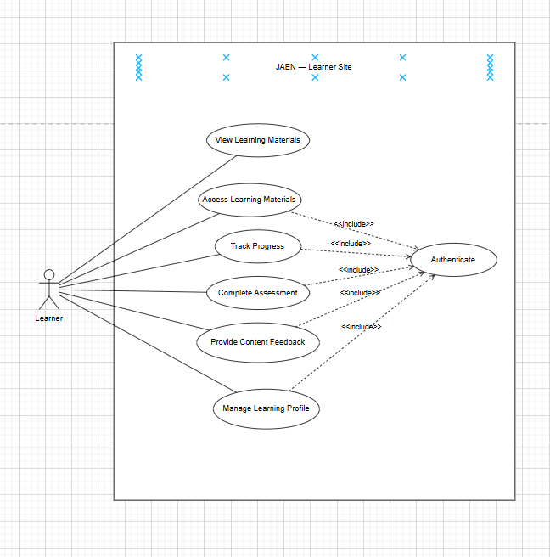

Figure I-2 Overview Use Case Diagram of Learner Site

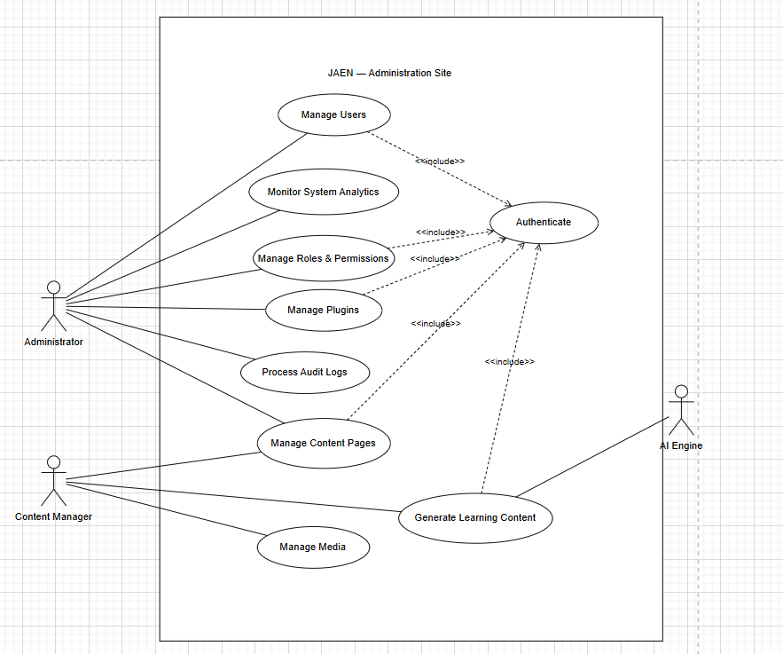

Figure I-3 Overview Use Case Diagram of Admin Site

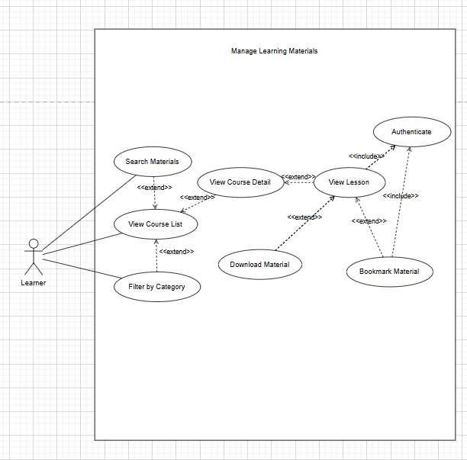

Figure I-4 Detailed Use Case Diagram for Manage Learning Materials

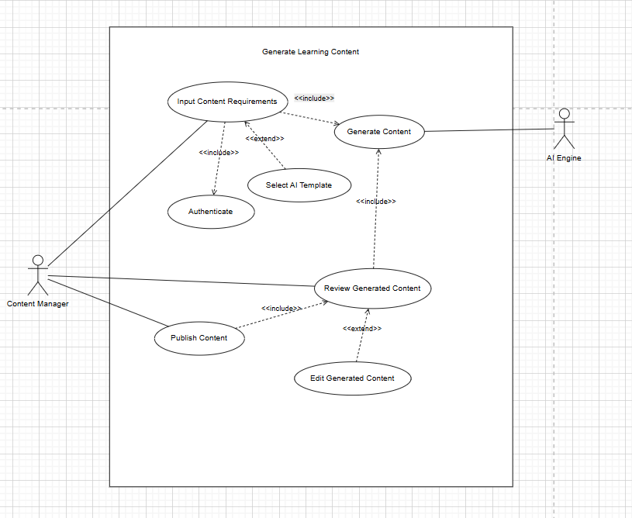

Figure I-5 Detailed Use Case Diagram for Generate Learning Content

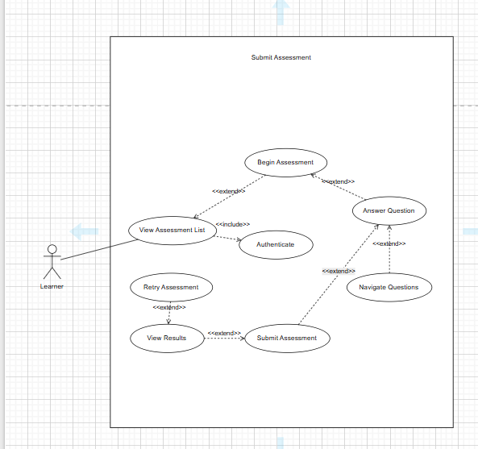

Figure I-6 Detailed Use Case Diagram for Submit Assessment

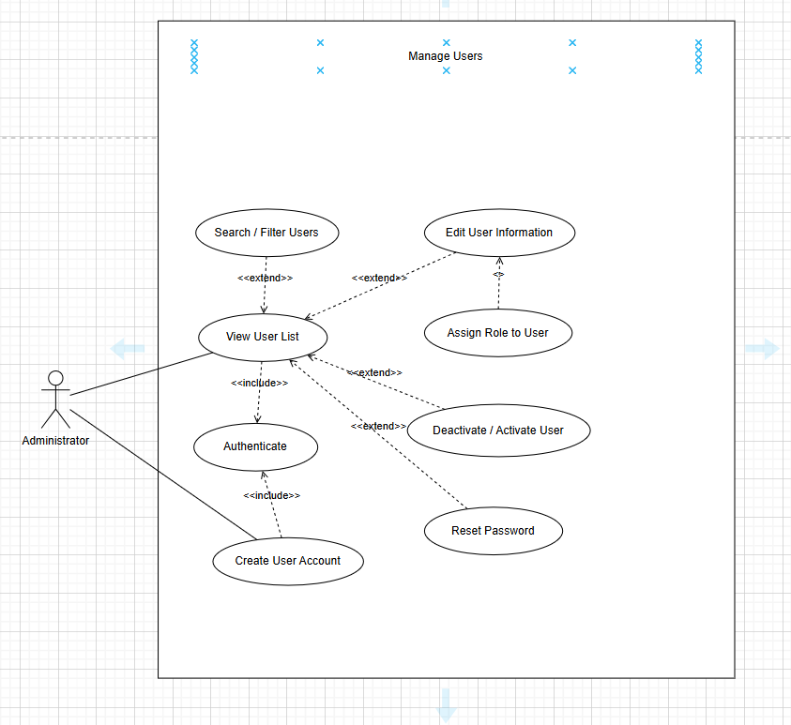

Figure I-7 Detailed Use Case Diagram for Manage Users

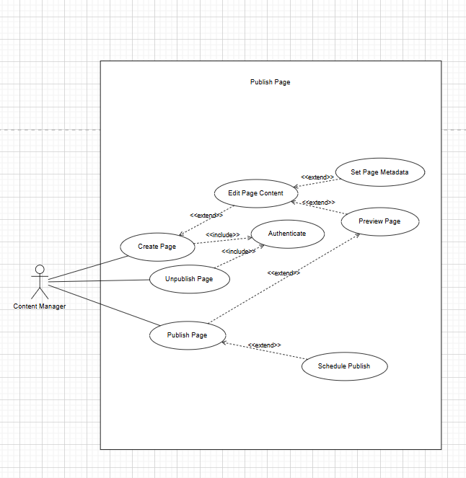Figure I-9 Detailed Use Case Diagram for Publish Page

I.5.2 Use case descriptions
Tables I-1 to I-5 describe the use cases: Manage Learning Materials, Generate Learning Content, Submit Assessment, Manage Users, and Publish Page. The event flows of these use cases can be modeled using activity diagrams. For example, Figures I-12 and I-13 are activity diagrams modeling the event flows of the Manage Learning Materials and Submit Assessment use cases.

Table I-1 Use case description for manage learning materials
ID and Name: | UC-01 Manage Learning Materials
Created By: | ThanhPTV | Date Created: | 17/06/2026
Primary Actor: | Learner | Secondary Actors: | Content Manager
Description: | This use case allows the Learner to view, search, filter, and access learning materials including courses, lessons, and downloadable resources on the JAEN platform.
Trigger: | The Learner selects the Learning Materials option from the Learner Site menu.
Preconditions: | PRE-1. Learner has an active account on the JAEN platform.  PRE-2. Learning materials have been published by the Content Manager.  PRE-3. Learner is authenticated to access protected content.
Postconditions: | POST-1. Learner has successfully viewed or accessed the desired learning material.  POST-2. The system has recorded the learner's progress.
Normal Flow: | 1. The Learner navigates to the Learning Materials section.  2. The system retrieves the list of available courses from the database.  3. The system displays the course list with title, category, and progress.  4. The Learner searches by keyword or filters by category.  5. The system displays matching results.  6. The Learner selects a course to view its details.  7. The system displays course details including outline and lessons.  8. The Learner selects a lesson to view.  9. The system displays lesson content and updates the learner's progress.  10. The Learner optionally downloads materials or bookmarks the lesson.
Alternative Flows: | AF-1. Learner browses without filtering: System displays all materials in default order.  AF-2. Learner bookmarks a lesson: System saves the bookmark to the learner's profile.  AF-3. Learner downloads a material: System validates access rights and initiates download.
Exceptions: | EX-1. No materials available: System displays "No learning materials found."  EX-2. Learner not authenticated for protected content: System redirects to Login.  EX-3. Learner lacks download permission: System displays an access denied message.
Priority: | High
Business Rules: | Learner must be authenticated to access lesson content, download materials, or bookmark lessons. Public course listings may be visible without authentication.

Table I-2 Use case description for generate learning content
ID and Name: | UC-02 Generate Learning Content
Created By: | ThanhPTV | Date Created: | 17/06/2026
Primary Actor: | Content Manager | Secondary Actors: | AI Engine (System)
Description: | This use case allows the Content Manager to use AI-powered tools on the JAEN Administration Site to generate learning materials. The AI Engine processes input requirements and produces draft content for the Content Manager to review, edit, and publish.
Trigger: | The Content Manager selects the Generate Learning Content option from the Administration Site.
Preconditions: | PRE-1. Content Manager is authenticated on the Administration Site.  PRE-2. AI Engine service is available and properly configured.  PRE-3. Content Manager has content creation permissions.
Postconditions: | POST-1. AI-generated content is saved as a draft or published to the platform.  POST-2. Content is accessible to learners if published.
Normal Flow: | 1. The Content Manager navigates to the Generate Learning Content section.  2. The Content Manager inputs content requirements (topic, objectives, level, format).  3. The Content Manager submits the generation request.  4. The system sends the request to the AI Engine.  5. The AI Engine processes the request and generates draft content.  6. The system displays the generated content for review.  7. The Content Manager reviews the generated content.  8. The Content Manager publishes the content or saves it as a draft.
Alternative Flows: | AF-1. Select AI Template: Content Manager selects a template; system pre-fills input fields.  AF-2. Edit generated content: Content Manager modifies text or structure before publishing.  AF-3. Save as draft: System saves content without publishing for later editing.
Exceptions: | EX-1. Required fields missing: System highlights empty fields and prevents submission.  EX-2. AI Engine fails to generate: System displays an error and prompts retry.  EX-3. AI Engine timeout: System notifies the Content Manager and offers a retry option.
Priority: | High
Business Rules: | Generated content must be reviewed and approved by a Content Manager before publication.

Table I-3 Use case description for submit assessment
ID and Name: | UC-03 Submit Assessment
Created By: | ThanhPTV | Date Created: | 17/06/2026
Primary Actor: | Learner | Secondary Actors: | —
Description: | This use case allows the Learner to take and submit an assessment to evaluate their understanding of a learning module. Upon submission, the system calculates the score and provides detailed feedback.
Trigger: | The Learner selects an assessment from the Assessments section on the Learner Site.
Preconditions: | PRE-1. Learner is authenticated on the JAEN platform.  PRE-2. The assessment is published and available to the learner.  PRE-3. The assessment has not exceeded its deadline (if applicable).
Postconditions: | POST-1. Assessment answers are recorded in the system.  POST-2. Score and feedback are calculated and displayed to the learner.  POST-3. Learner's progress is updated accordingly.
Normal Flow: | 1. The Learner navigates to the Assessments section.  2. The system displays a list of available assessments.  3. The Learner selects an assessment to take.  4. The system displays assessment instructions and rules.  5. The Learner clicks "Begin Assessment."  6. The system displays the first question.  7. The Learner selects or enters an answer.  8. The Learner navigates to the next or previous question.  9. The Learner repeats steps 7–8 until all questions are answered.  10. The Learner clicks "Submit Assessment."  11. The system validates and records the submitted answers.  12. The system calculates and displays the score and feedback.
Alternative Flows: | AF-1. Skip question: Learner skips a question; unanswered questions can be revisited later.  AF-2. Pass assessment: System marks module as completed and unlocks the next module.  AF-3. Fail assessment: System displays remediation suggestions and offers retry if permitted.
Exceptions: | EX-1. Assessment already completed, retry not allowed: System displays previous results.  EX-2. Network interruption during submission: System retains answers and prompts resubmission.  EX-3. Session expires during assessment: System auto-saves progress; learner re-authenticates to continue.
Priority: | High
Business Rules: | Learner must be authenticated to take an assessment. Maximum retry attempts are configured per assessment by the administrator.

Table I-4 Use case description for manage users
ID and Name: | UC-04 Manage Users
Created By: | ThanhPTV | Date Created: | 17/06/2026
Primary Actor: | Administrator | Secondary Actors: | —
Description: | This use case allows the Administrator to manage user accounts on the JAEN Administration Site, including creating accounts, editing information, assigning roles, resetting passwords, and deactivating or activating users.
Trigger: | The Administrator selects the User Management option from the Administration Site menu.
Preconditions: | PRE-1. Administrator is authenticated on the Administration Site.  PRE-2. Administrator has user management permissions.
Postconditions: | POST-1. User account is created, updated, or deactivated as requested.  POST-2. All changes are immediately reflected in the system.
Normal Flow: | 1. The Administrator navigates to the User Management section.  2. The system retrieves and displays a paginated list of registered users.  3. The Administrator searches by name/email or filters by role/status.  4. The system displays filtered results.  5. The Administrator selects a user account.  6. The Administrator performs the desired action (see Alternative Flows).  7. The system validates and applies the changes.  8. The system confirms the action with a success notification.
Alternative Flows: | AF-1. Create new user: Administrator fills in details and submits; system creates account and sends welcome email.  AF-2. Edit user information: Administrator modifies details and saves; system updates the account.  AF-3. Assign/change role: Administrator selects a role; system updates user permissions.  AF-4. Deactivate user: Administrator confirms; system disables the account.  AF-5. Reset password: System sends a password reset link to the user's email.
Exceptions: | EX-1. Email address already exists: System displays a duplicate email error.  EX-2. Invalid or missing required fields: System highlights errors and prevents saving.  EX-3. Administrator attempts to deactivate own account: System displays a restriction error.
Priority: | High
Business Rules: | Administrators cannot deactivate their own account. Email addresses must be unique across all user accounts in the system.

Table I-5 Use case description for publish page
ID and Name: | UC-05 Publish Page
Created By: | ThanhPTV | Date Created: | 17/06/2026
Primary Actor: | Content Manager | Secondary Actors: | —
Description: | This use case allows the Content Manager to create, edit, preview, and publish content pages on the JAEN platform. Pages can be published immediately or scheduled for a future date and time.
Trigger: | The Content Manager selects the Content Pages option from the Administration Site menu.
Preconditions: | PRE-1. Content Manager is authenticated on the Administration Site.  PRE-2. Content Manager has page creation and publishing permissions.
Postconditions: | POST-1. The page is published and accessible to the intended audience.  POST-2. Page metadata and SEO settings are saved.  POST-3. If scheduled, the page is queued for future publication.
Normal Flow: | 1. The Content Manager navigates to the Content Pages section.  2. The Content Manager clicks "Create New Page."  3. The Content Manager edits page content using the WYSIWYG editor.  4. The Content Manager sets page metadata (title, description, URL slug, SEO tags).  5. The Content Manager clicks "Preview" to review the page.  6. The system renders and displays a preview of the page.  7. The Content Manager clicks "Publish."  8. The system publishes the page and makes it publicly accessible.  9. The system displays a confirmation message with the page URL.
Alternative Flows: | AF-1. Edit existing page: Content Manager selects existing page and modifies content or settings.  AF-2. Schedule publish: Content Manager sets a future date/time; system auto-publishes at that time.  AF-3. Unpublish page: Content Manager unpublishes a live page; system hides it while retaining content.
Exceptions: | EX-1. Unsaved changes on exit: System prompts to save as draft or discard changes.  EX-2. Preview fails due to rendering error: System displays error and allows continued editing.  EX-3. URL slug already in use: System displays conflict error and prompts for a different slug.
Priority: | High
Business Rules: | URL slugs must be unique across all pages. Scheduled pages are published automatically at the configured time without manual intervention.

I.5.3 Activity diagrams
Figures 1-12 is activity diagrams modeling event flows of the use case Generate Learning Content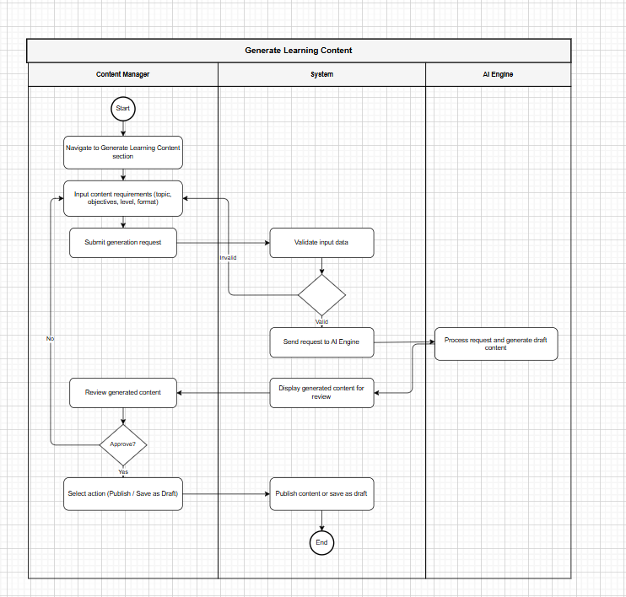
Figure I-12 Activity diagram modeling event flows of use case Generate Learning Content

I.6 Data Requirements

II. Analysis models

II.1 Interaction diagrams
In this section, we will analyze objects and their interactions to realize use cases based on the MVC model's analysis pattern. Specifically, we will examine the following use cases: Manage Products, Add Product, Edit Product, Delete Product, Disable News, and Enable News. The interaction diagrams, illustrated in Figures 2-1 through 2-12 include sequence diagrams and communication diagrams that model the interactions (messages) of objects to realize these use cases.
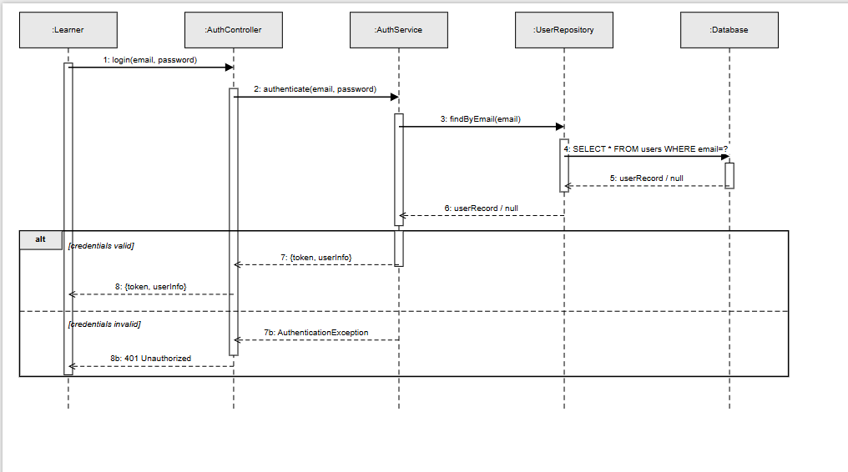

Figure II-1 Sequence Diagram for Authenticate Use Case

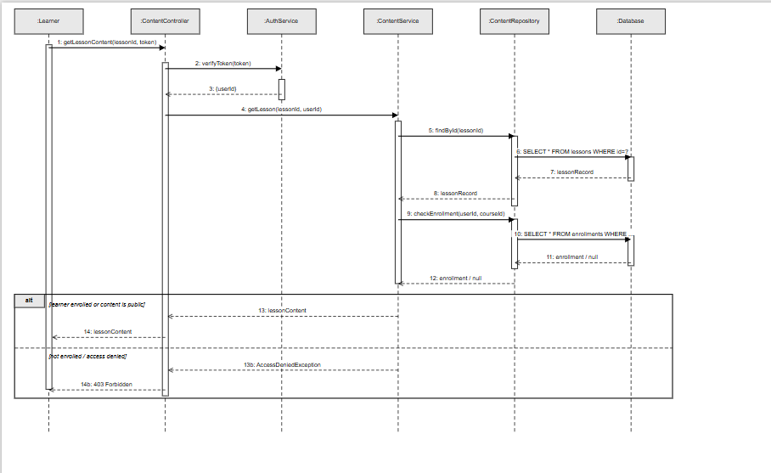 Figure II-2 Sequence Diagram for Access Learning Material Use Case
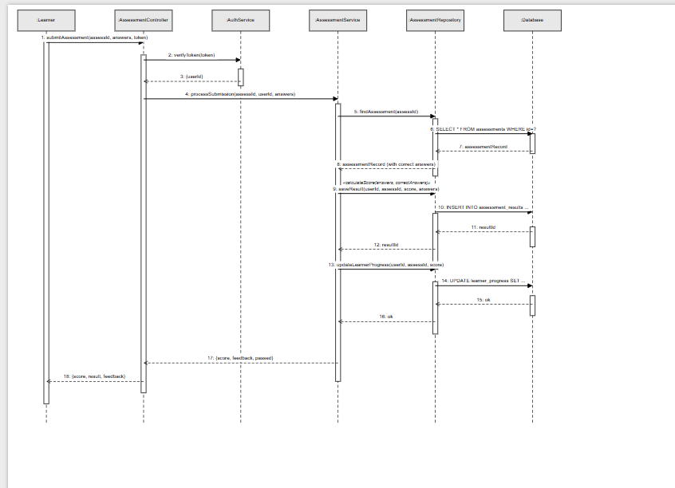Figure II-3 Sequence Diagram for Submit Assessment Use Case

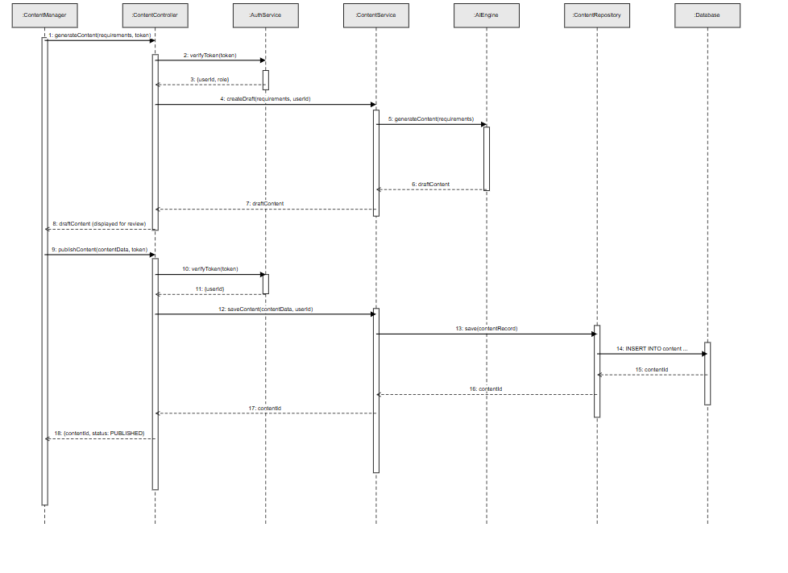

Figure II-4 Sequence Diagram for Generate Learning Content Use Case
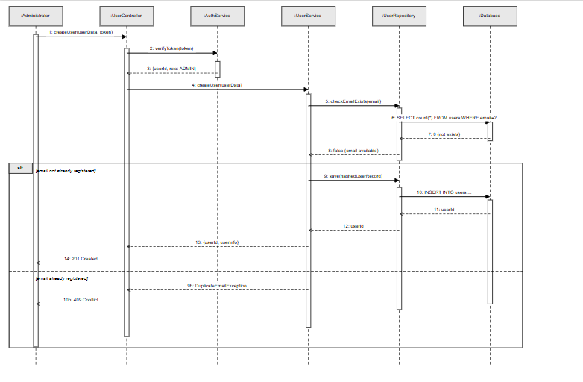

Figure II-5 Sequence Diagram for Create User Account

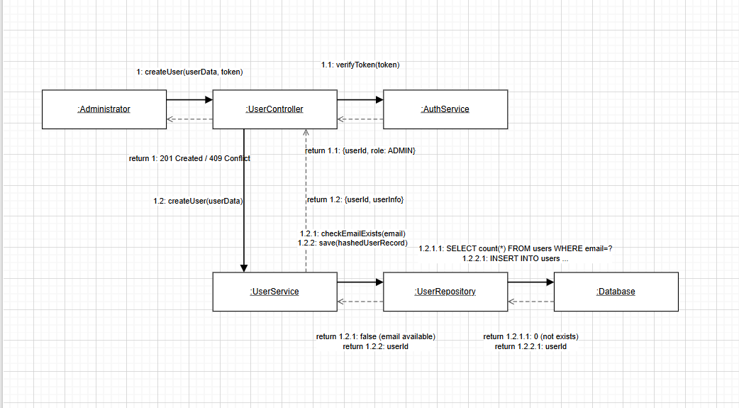

Figure II-6 Communication Diagram for Create User Account
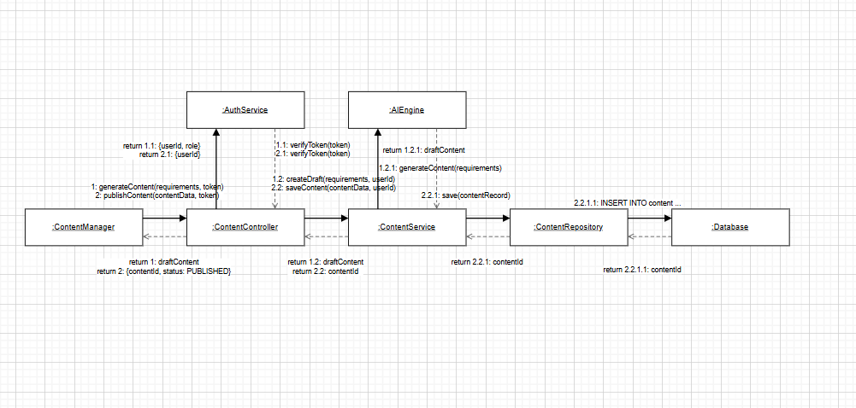

Figure II-7 Communication Diagram for Generate Learning Content

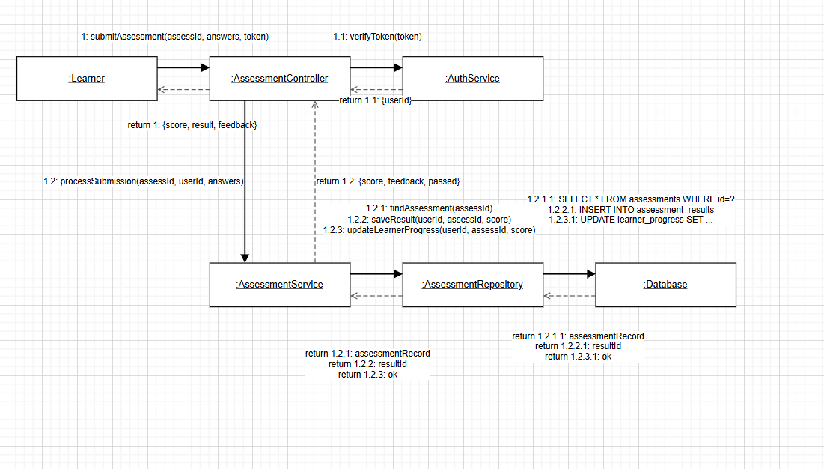

Figure II-9 Communication Diagram for Submit Assessment Use Case

II.2 State diagram
In object-oriented analysis and design, a finite state machine (FSM) models the states and state transitions of a system or an object. The events that trigger state transitions share the same names as messages arriving at state-dependent objects in the sequence diagrams and communication diagrams defined in the preceding sections, ensuring behavioral models remain aligned with interaction models throughout the system design.
In the JAEN ecosystem, finite state machines are utilized to model the dynamic behaviors, lifecycle phases, and operational constraints of core domain entities. The transition events that trigger state updatessuch as AI content generation, authorization checking, assessment grading, enrollment validation, and account management are mapped directly to messages arriving at state-dependent objects within the previously defined interaction models.
The JAEN ecosystem explicitly defines, implements, and monitors the behavioral state lifecycles for the following five critical domain objects:
- Course Object (Figure II - 13): Outlines the full collaborative authoring lifecycle of instructional courses from creator draft mode, automated virus scans, and admin metadata audits to active public catalog streaming.
- AssessmentJob Object (Figure II - 14): Models the asynchronous processing pipeline, internal payload validation, and exponential backoff retry mechanics of the AI-powered language evaluation engine.
- ModerationCase Object (Figure II - 15): Tracks policy violation tickets from initial user-generated reports, through automated/manual analysis and soft-hiding, to permanent material removal or dismissal.
- Order / Payment Object (Figure II - 16): Governs financial transactions securely processed via external financial gateways from initial intent capture to asynchronous webhook fulfillment, expiration, or refunding.
- VocabularyCard / Flashcard Object (Figure II - 17): Operates the dynamic personalization loop driven by the Spaced Repetition System (SRS) algorithm, adjusting retention intervals based on real-time feedback scores submitted by the Learner.

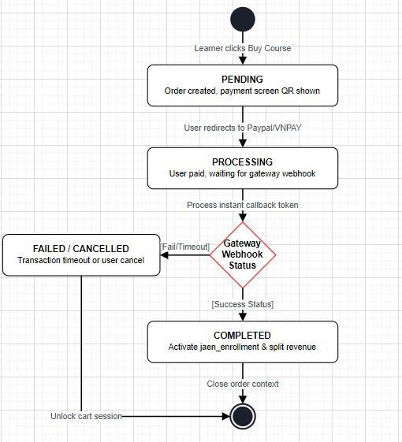
Figure II-13 State diagram model states of course object

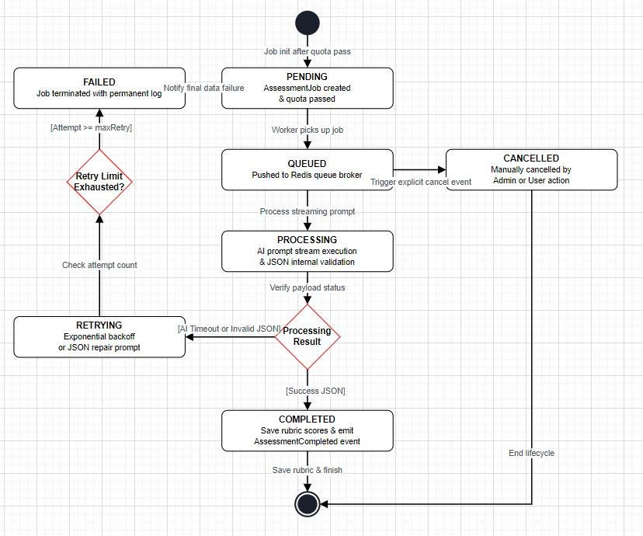
Figure II-14 State diagram model states of an AI assessment object

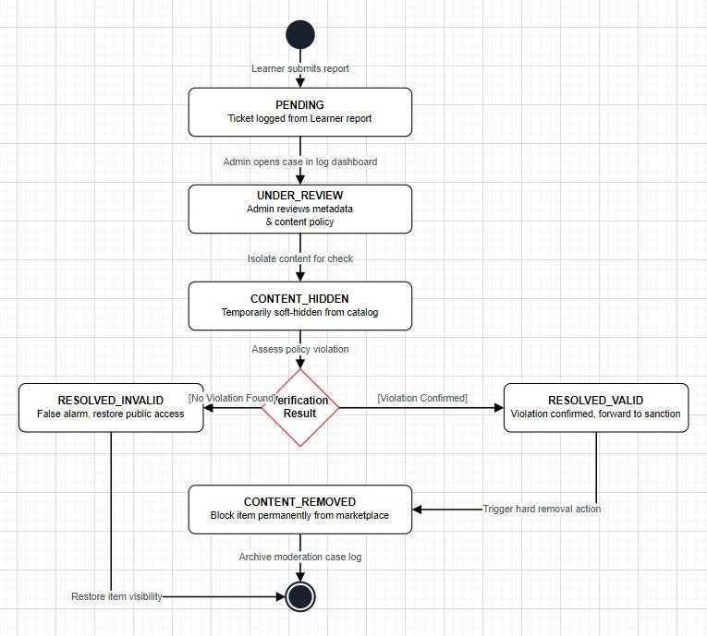
Figure II-15 State diagram model states of a Moderation case

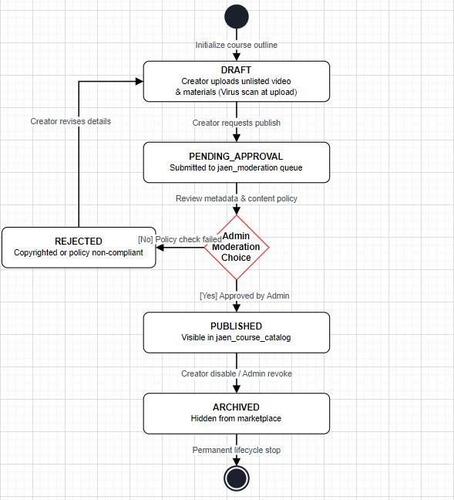
Figure II-16 State diagram model states of a Order/Payment course

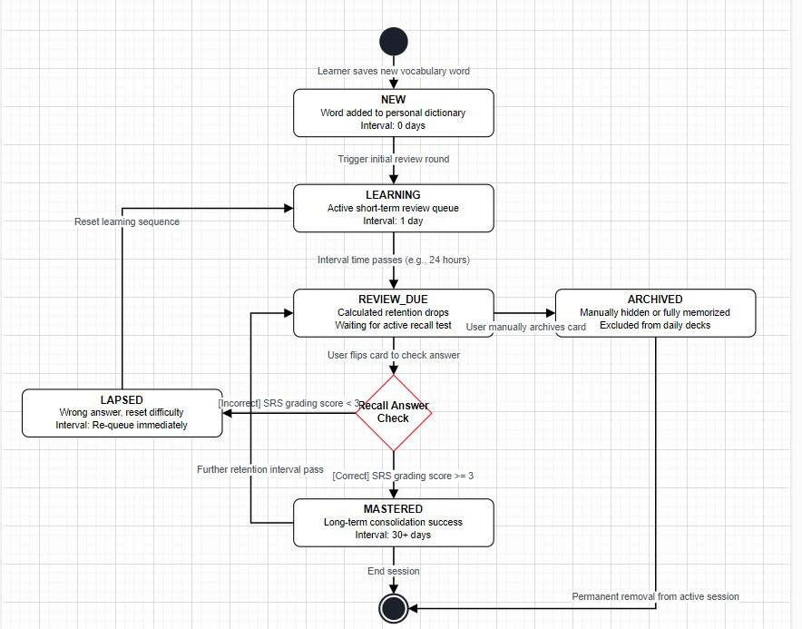
Figure II-17 State diagram model states of a Flashcard object

